Growing shade   
Interactive RESOURCE

User Guide

White Bar Art

The Council’s mission is to foster  
efficient and economic growth for   
a prosperous metropolitan region

**Metropolitan Council Members**

|  |  |
| --- | --- |
| Charlie Zelle Chair Judy Johnson District 1 Reva Chamblis District 2 Christopher Ferguson District 3 Deb Barber District 4 Molly Cummings District 5 Lynnea Atlas-Ingebretson District 6 Robert Lilligren District 7 Abdirahman Muse District 8 | Raymond Zeran District 9 Peter Lindstrom District 10 Susan Vento District 11 Francisco J. Gonzalez District 12 Chai Lee District 13 Kris Fredson District 14 Phillip Sterner District 15 Wendy Wulff District 16 |

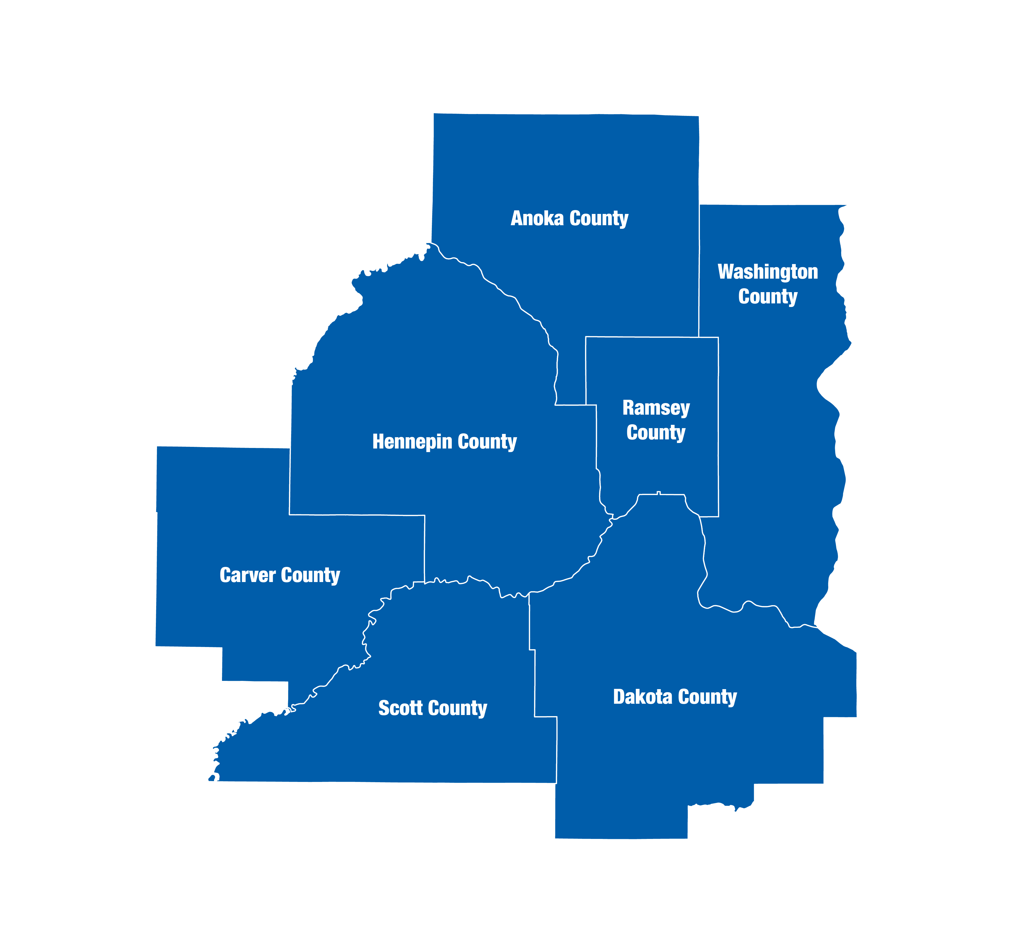  
The Metropolitan Council is the regional planning organization   
for the seven-county Twin Cities area. The Council operates the regional bus and rail system, collects and treats wastewater, coordinates regional water resources, plans and helps fund regional parks, and administers federal funds that provide housing opportunities for low- and moderate-income individuals and families. The 17-member Council board is appointed by and serves at the pleasure of the governor.

On request, this publication will be made available in alternative formats to people with disabilities. Call Metropolitan Council information at 651-602-1140 or TTY 651-291-0904.

# Introduction

## Why was the Growing Shade Project created?

**Trees help communities thrive.** Community-wide benefits from trees include cooler temperatures, improved air quality, cleaner stormwater, improved mental health, and enhanced biodiversity. Enhancing tree canopy cover is an actionable step to create healthy and resilient places. The Growing Shade Project provides data and resources to inform tree planting and canopy preservation for the Twin Cities region.

**Trees connect to regional issues and priorities.** Public health, environmental justice, climate change, and natural resource conservation all intersect with the tree canopy. Tree planting efforts and ongoing maintenance will benefit from new perspectives, rigorous science, and thoughtful synthesis. Growing Shade was developed for planners and foresters but is available to anyone who wants this information. Stakeholder engagement remains essential to understand community-specific concerns and opportunities for enhancing, preserving, and maintaining the tree canopy.

Growing Shade is an interactive resource to inform tree canopy enhancement and preservation for the Twin Cities region.

# User Interface

To begin using the tool, notice the tabs on the top of the screen. Navigate to different parts of the tool by clicking on the tabs. This document goes through each tab in detail.

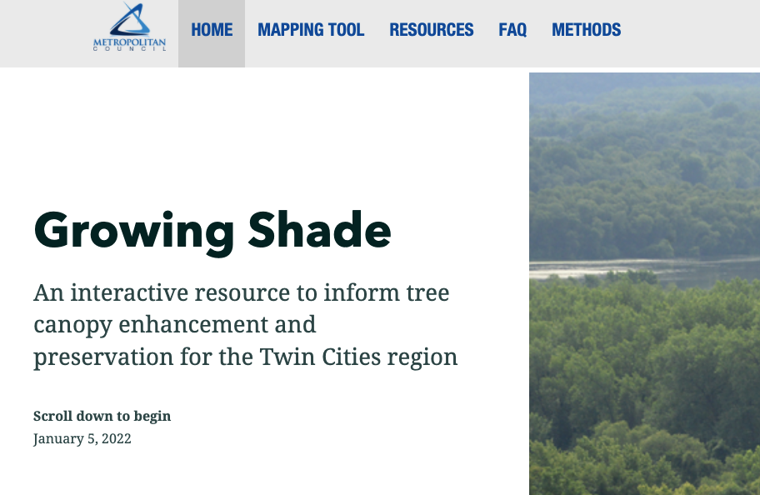

Click the tabs on top of the screen to navigate the tool

## “Home” tab

On the home page, scroll down to find a general overview about what this tool does, and ways in which you might find this tool useful. Learn about the regional issues and priorities intersecting with the tree canopy. Five stories with unique themes are profiled on this “home” tab.

## “Mapping tool” tab

This tab allows users to create data-driven reports for communities across the Twin Cities. This page has three main components: 1) a place for users to customize the analyses, 2) a map of tree canopy prioritization and existing canopy cover, 3) a user-generated report.

An overview of the mapping tool is shown below.

Report

Customizations

Map

Toggle map layers “on” or “off”.

Use the buttons or scroll to zoom in and out. View the current tree canopy by zooming in.

Scroll down to read the report. Collapse report sections by clicking on the “minus” sign. Alternatively, download the report or raw data.

Select the geography for the report. For cities or neighborhoods, use the dropdown menu. For block groups, click an area on the map.

Click for information about using this tool.

Select a preset (or “custom”) prioritization layer. Click the question mark for help.

Get a “full screen” mode for the map.

To customize the map, select a “preset” on the left of the screen to create a tree canopy enhancement or maintenance priority layer. Selecting “custom” activates several drop down menus from which inputs can be selected. Click on a variable to turn in “on” or “off” – a “check mark” indicates that the input is being used to calculate priority scores. You can also “select all” or “deselect all” variables within a drop down menu.

More information about presets.

Select “custom” to activate more options.

A checkmark indicates this variable is being used to calculate priority scores. Click the variable to turn on or off.

Click the question mark for more information about the presets and priority scoring.

To create a report, select the geography of interest. If a “city or township” or “neighborhood” is selected, use the drop down menu to specify for which area the report should be created. If a “census block group” is selected, please click on an area within the map to create a report.

Scroll down to read the report. Alternately, download the report or the raw data. The figures and information in both reports are the same. The downloaded report can be printed and may be more useful for sharing.

Within the report, each section can be collapsed by clicking on the “minus” or “plus” symbol. This may be useful if you wish to compare a specific report selection across different geographies.

Zoom in on the map to view the current tree canopy (“tree” layer). We recommend taking a screenshot of the map if you will need this information offline (instructions [for mac](https://support.apple.com/en-us/HT201361) and [for windows](https://support.microsoft.com/en-us/windows/use-snipping-tool-to-capture-screenshots-00246869-1843-655f-f220-97299b865f6b)).

Toggle map layers on or off.

“Resources” tab

This tab provides links to other tools which may be useful and methodological information.

“FAQ” tab

This tab provides answers to frequently asked questions..

“Methods” tab

This tab provides an overview of how data was processed for this project.

­390 Robert Street North  
Saint Paul, MN 55101-1805

651.602.1000  
TTY 651.291.0904  
[public.info@metc.state.mn.us](mailto:public.info@metc.state.mn.us)  
metrocouncil.org

Follow us on:  
twitter.com/metcouncilnews  
facebook.com/MetropolitanCouncil  
youtube.com/MetropolitanCouncil

